**PROCESSES IN UNIX**

**LAB # 3**



**Fall 2022**

**CSE-302L Systems Programming Lab**

**Submitted by**:

Maaz Habib

**Registration number:**

20PWCSE1952

**Class Section:**

**C**

“On my honor, as a student of University of Engineering and Technology, I have neither given nor received unauthorized assistance on this academic work”

Submitted to:

**Engr. Abdullah Hamid**

Tuesday November 1, 2022

Department of Computer Systems Engineering

University of Engineering and Technology, Peshawar

**3.1. UNIX Process Creation and fork:**

A process can create a new process by calling fork. The calling process becomes the parent, and the created process is called the child. The fork function copies the parent's memory image so that the new process receives a copy of the address space of the parent. Both processes continue at the instruction after the fork statement (executing in their respective memory images).

Creation of two completely identical processes would not be very useful. The fork function return value is the critical characteristic that allows the parent and the child to distinguish themselves and to execute different code. The fork function returns 0 to the child and returns the child's process ID to the parent. When fork fails, it returns –1 and sets the errno.

**3.2. The wait Function:**

When a process creates a child, both parent and child proceed with execution from the point of the fork. The parent can execute wait or waitpid to block until the child finishes. The wait function causes the caller to suspend execution until a child's status becomes available or until the caller receives a signal. A process status most commonly becomes available after termination, but it can also be available after the process has been stopped.

The waitpid function allows a parent to wait for a particular child. The waitpid function takes three parameters: a pid, a pointer to a location for returning the status and a flag specifying options. If pid is –1, waitpid waits for any child. If pid is greater than 0, waitpid waits for the specific child whose process ID is pid. Two other possibilities are allowed for the pid parameter. If pid is 0, waitpid waits for any child in the same process group as the caller

**4.2.1. Status values:**

The stat_loc argument of wait or waitpid is a pointer to an integer variable. If it is not NULL, these functions store the return status of the child in this location. The child returns its status by calling exit, _exit, _Exit or return from main. A zero return value indicates EXIT_SUCCESS; any other value indicates EXIT_FAILURE. The parent can only access the 8 least significant bits of the child's return status.

The six macros are designed to be used in pairs. The WIFEXITED evaluates to a nonzero value when the child terminates normally. If WIFEXITED evaluates to a nonzero value, then WEXITSTATUS evaluates to the low-order 8 bits returned by the child through _exit(), exit() or return from main.

**TASKS:**

**Task 1:**

Create process chain as shown in figure 3.1(b) and fill the figure 3.1 (b) with actual IDs. The program shall take a single command-line argument that specifies the number of processes to be created. Before exiting, each process shall output its i value (loop variable), its process ID (using getpid()), its parent process ID (getppid()) and the process ID of its child (return value of fork). The parent does not execute wait.

**Code:**

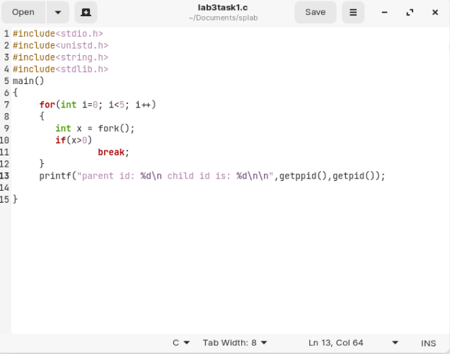

**Output:**

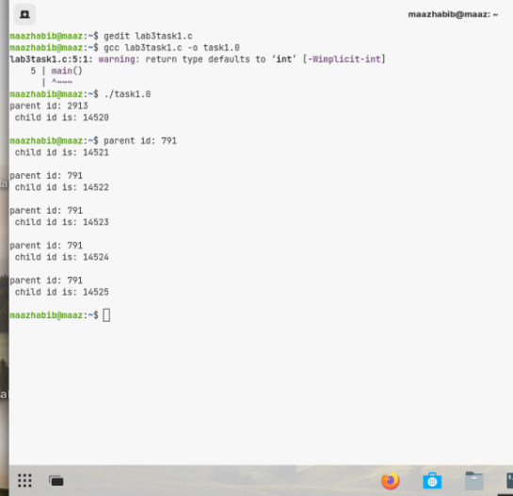

14521

14520

14522

14523

14524

1452yyyyyyyyyyyyyyyyyyyyyyyyyyyyyyyyyyyyyyyyyyyyyyyyyyyyyyyyyyyyyyyyyyyyyyyyyyyyyyyyyyyyyyyyyyyyyyyyyyyyyyyyyyyyyyyyyy

**Task 2:** Create process fan as shown in figure 3.1 (a) and fill the figure 3.1 (a) with actual IDs.

**Code:**

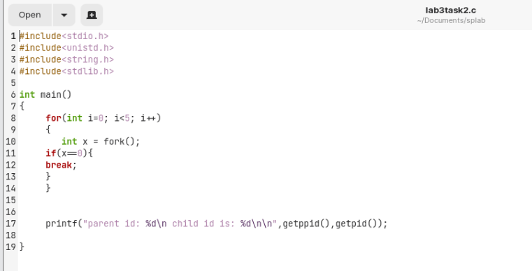

**Output:**

791

4

16451

51

16450

16449

16448

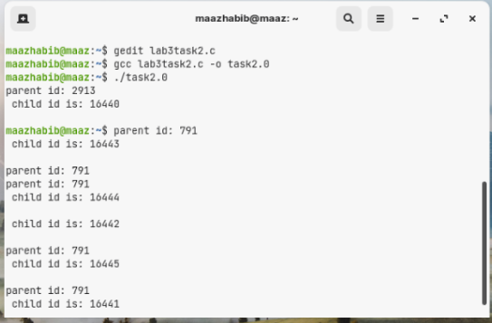

**Task 3:**

Creates a chain of processes. It takes a single command-line argument that specifies the number of processes to create. Before……………… processes may indicate a parent process ID of 1.

**Code:**

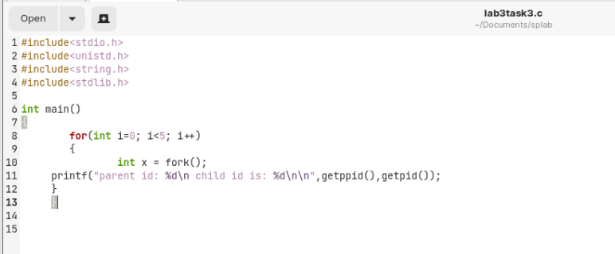

**Output:**

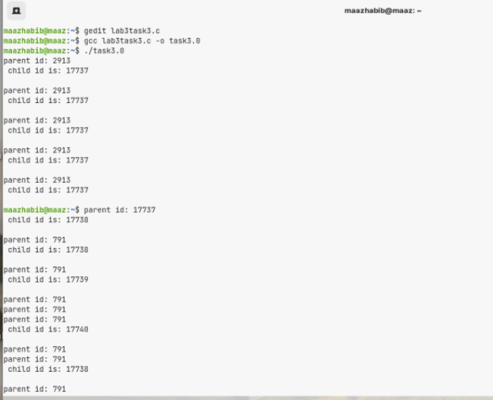

**Figure of Process Tree:**

17737

17742

17737

17742

17741

2913

17740

17738

17744

17737

17743

17739

17742

10

17738

17739

17740

17741

In my case, the orphan processes got adopted by BASH whose process id is “2913”. This adoption happened because I didn’t use “wait()” system call.

**Task4:**

Creates a chain of processes. It takes a single command-line argument that specifies the number of process……………………………. processes may indicate a parent process ID of 1.

**Code:**

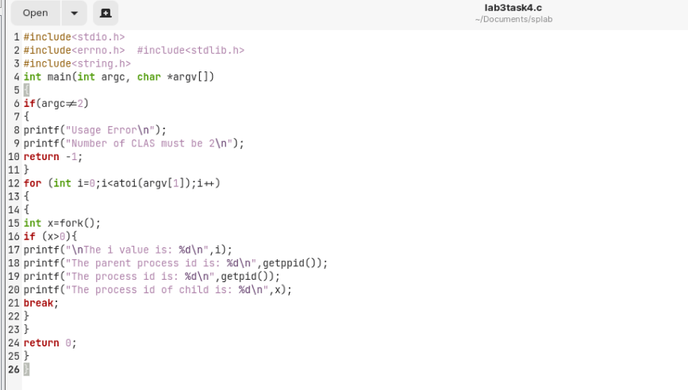

**Output:**

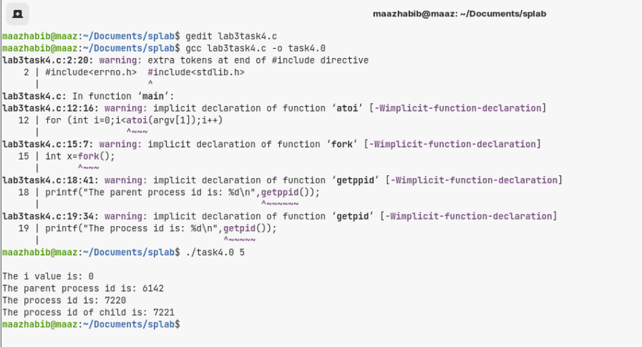

**Task 5:**

Write a program that takes N number of integers as argument and displays the factorials of N integers (print 1 only if integers are not less than zero, 0 or 1). Create separate child process for each integer. Make sure no child is orphan/zombie.

**Code:**

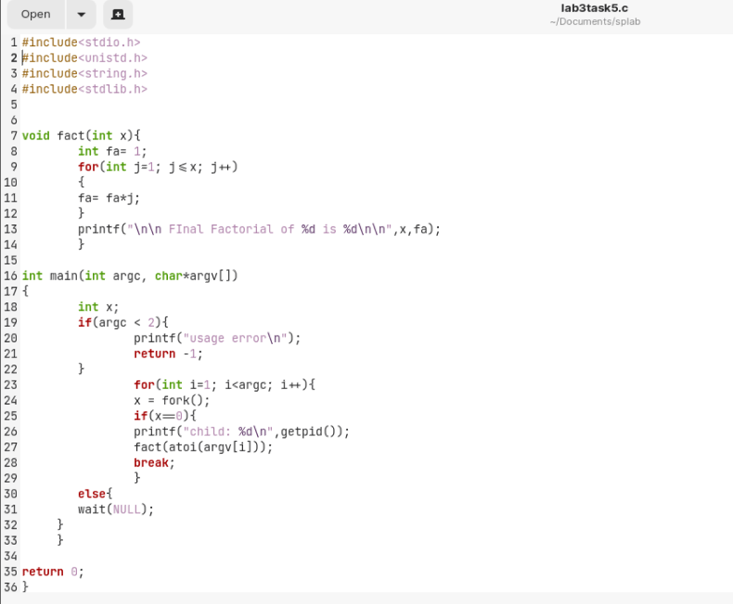

**Output:**

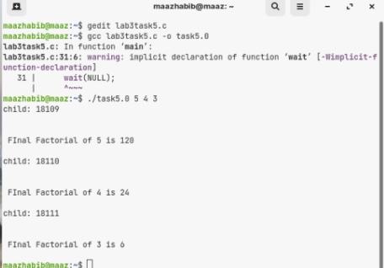

**Task 6:**

Write a program that creates an will add the results and display a final sum.

**Code:**

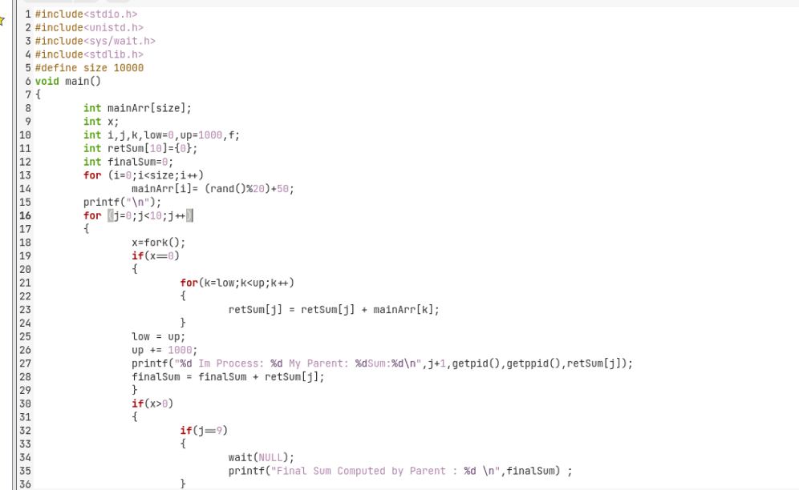

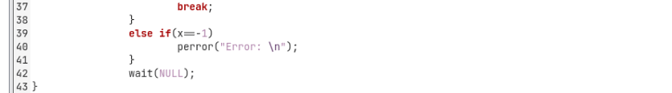

**Output:**

